**NATIONAL COLLEGE OF ENGINEERING**

**(Affiliated to Tribhuvan University)**

**Talchhikhel, Lalitpur**



**Computer graphics**

**Project on:**

**“Tic Tac Toe”**

|  |  |
| --- | --- |
| **Submitted By:**  Aayush Shrestha  077BCT002  Group: A1 | **Submitted To:**  Department of Electronics & Computer Engineering |

Table of Contents

Introduction: 3

Functions Used: 3

1. initgraph(): 3

2. cleardevice(): 3

3. line(): 3

4. ismouseclick(): 3

5. getmouseclick(): 4

6. circle(): 4

7. outtextxy(): 4

8. setcolor(): 4

9. settextstyle(): 4

10. delay(): 4

11. getch(): 4

12. closegraph(): 4

Expected Output: 5

SourceCode: 5

Output: 11

Conclusion: 12

Introduction:

The project involves developing a Tic Tac Toe game in C++ using the **graphics.h** library. The game provides an interactive interface where two players can take turns using mouse clicks to place their 'X' or 'O' symbols on a 3x3 grid. The implementation includes basic graphics functions to draw the grid, symbols, and detect win conditions. The project aims to create an engaging and visually appealing gaming environment, showcasing the integration of C++ programming with graphics functionalities. The game runs on older versions of Turbo C++ and offers an opportunity to explore graphics programming concepts while enjoying the classic Tic Tac Toe gameplay.

Objective:

The main objectives of this project are: -

* To learn and implement different features of graphics in C
* To interface the applications of graphics to the real world
* To familiarize with Graphics and its logical coding

Functions Used:

The functions used in this project are as follows:

1. initgraph(): This function initializes the graphics system and sets up the graphics window. It is the first function called when using the `graphics.h` library and prepares the environment for graphics-related operations.

2. cleardevice(): The `cleardevice()` function clears the entire graphics window by filling it with the background color. It is typically used before redrawing the contents of the window to prevent overlapping or artifacts.

3. line(): This function draws a straight line between two specified points on the graphics window. It takes the coordinates of the starting and ending points as its arguments and uses the current drawing color.

4. ismouseclick(): The `ismouseclick()` function checks whether a mouse click event has occurred. It is used to detect mouse interactions and is often paired with `getmouseclick()` to retrieve details about the mouse click.

5. getmouseclick(): When used with `ismouseclick()`, this function retrieves the details of a mouse click event, such as the button pressed (left, right, middle), and the coordinates (x and y) of the click on the graphics window.

6. circle(): The `circle()` function draws a circle on the graphics window. It requires the center coordinates and the radius as arguments. The current drawing color is used to render the circle.

7. outtextxy(): This function displays text on the graphics window at the specified coordinates (x, y). It allows developers to add textual information to the graphical user interface.

8. setcolor(): The `setcolor()` function sets the current drawing color. It allows developers to choose the color for lines, shapes, and text to be drawn on the graphics window.

9. settextstyle(): This function sets the font style and size for text to be displayed using `outtextxy()`. It allows developers to customize the appearance of the text.

10. delay(): The `delay()` function pauses the program execution for a specified number of milliseconds. It is commonly used to introduce delays between graphics-related operations, creating animations, or controlling game speed.

11. getch(): The `getch()` function waits for a key press from the user. It is often used to halt the program's execution until the user provides input, making it useful for handling user interactions.

12. closegraph(): This function closes the graphics window and releases any resources allocated by the `initgraph()` function. It ensures that the graphics environment is safely shut down before the program terminates.

# Expected Output:

Tic Tac Toe

|  |  |  |
| --- | --- | --- |
| O | X | O |
| O | X | X |
| X | O | X |

# SourceCode:

#include <iostream>

#include <conio.h>

#include <graphics.h>

using namespace std;

const int WINDOW_SIZE = 300;

const int CELL_SIZE = WINDOW_SIZE / 3;

void drawBoard() {

line(CELL_SIZE, 0, CELL_SIZE, WINDOW_SIZE);

line(2 * CELL_SIZE, 0, 2 * CELL_SIZE, WINDOW_SIZE);

line(0, CELL_SIZE, WINDOW_SIZE, CELL_SIZE);

line(0, 2 * CELL_SIZE, WINDOW_SIZE, 2 * CELL_SIZE);

}

char checkWin(char board[3][3], int& x1, int& y1, int& x2, int& y2) {

// Check rows and columns

for (int i = 0; i < 3; ++i) {

if (board[i][0] == board[i][1] && board[i][1] == board[i][2] && board[i][0] != ' ') {

x1 = 0;

y1 = i * CELL_SIZE + CELL_SIZE / 2;

x2 = WINDOW_SIZE;

y2 = i * CELL_SIZE + CELL_SIZE / 2;

return board[i][0];

}

if (board[0][i] == board[1][i] && board[1][i] == board[2][i] && board[0][i] != ' ') {

x1 = i * CELL_SIZE + CELL_SIZE / 2;

y1 = 0;

x2 = i * CELL_SIZE + CELL_SIZE / 2;

y2 = WINDOW_SIZE;

return board[0][i];

}

}

// Check diagonals

if (board[0][0] == board[1][1] && board[1][1] == board[2][2] && board[0][0] != ' ') {

x1 = 0;

y1 = 0;

x2 = WINDOW_SIZE;

y2 = WINDOW_SIZE;

return board[0][0];

}

if (board[0][2] == board[1][1] && board[1][1] == board[2][0] && board[0][2] != ' ') {

x1 = WINDOW_SIZE;

y1 = 0;

x2 = 0;

y2 = WINDOW_SIZE;

return board[0][2];

}

// Check for draw

bool draw = true;

for (int i = 0; i < 3; ++i) {

for (int j = 0; j < 3; ++j) {

if (board[i][j] == ' ') {

draw = false;

break;

}

}

if (!draw)

break;

}

if (draw)

return 'D';

// Game still ongoing

return ' ';

}

void drawMove(int row, int col, char player) {

int x = col * CELL_SIZE + CELL_SIZE / 2;

int y = row * CELL_SIZE + CELL_SIZE / 2;

if (player == 'X') {

// Draw 'X'

line(x - 25, y - 25, x + 25, y + 25);

line(x - 25, y + 25, x + 25, y - 25);

} else if (player == 'O') {

// Draw 'O'

circle(x, y, 25);

}

}

int main() {

int gd = DETECT, gm;

initgraph(&gd, &gm, (char*)"");

char board[3][3] = {

{' ', ' ', ' '},

{' ', ' ', ' '},

{' ', ' ', ' '}

};

char currentPlayer = 'X';

char result;

int x1, y1, x2, y2; // Coordinates for the line

int lastRow, lastCol;

while (true) {

cleardevice();

drawBoard();

for (int i = 0; i < 3; ++i) {

for (int j = 0; j < 3; ++j) {

if (board[i][j] != ' ') {

drawMove(i, j, board[i][j]);

}

}

}

int mouseClick = 0;

while (!mouseClick) {

if (ismouseclick(WM_LBUTTONDOWN)) {

int x, y;

getmouseclick(WM_LBUTTONDOWN, x, y);

int row = y / CELL_SIZE;

int col = x / CELL_SIZE;

if (row >= 0 && row < 3 && col >= 0 && col < 3 && board[row][col] == ' ') {

board[row][col] = currentPlayer;

mouseClick = 1;

currentPlayer = (currentPlayer == 'X') ? 'O' : 'X';

lastRow = row;

lastCol = col;

}

}

}

// Check for win or draw

result = checkWin(board, x1, y1, x2, y2);

if (result == 'X') {

line(x1, y1, x2, y2); // Draw the winning line

drawMove(lastRow, lastCol, board[lastRow][lastCol]);

setcolor(RED);

settextstyle(SANS_SERIF_FONT, HORIZ_DIR, 3);

outtextxy((WINDOW_SIZE-textwidth("Player 1 wins!"))/2, WINDOW_SIZE / 2 + 150,(char*)"Player 1 wins!");

break;

}

else if(result == 'O') {

line(x1, y1, x2, y2); // Draw the winning line

drawMove(lastRow, lastCol, board[lastRow][lastCol]);

setcolor(RED);

settextstyle(SANS_SERIF_FONT, HORIZ_DIR, 3);

outtextxy((WINDOW_SIZE-textwidth("Player 2 wins!"))/2, WINDOW_SIZE / 2 + 150,(char*)"Player 2 wins!");

break;

}

else if (result == 'D') {

outtextxy((WINDOW_SIZE-textwidth("Its a Draw!"))/2, WINDOW_SIZE / 2 + 150,(char*)"Its a Draw!");

break;

}

delay(200);

}

getch(); // Wait for a key press before closing the graphics window

closegraph();

return 0;

# Output:

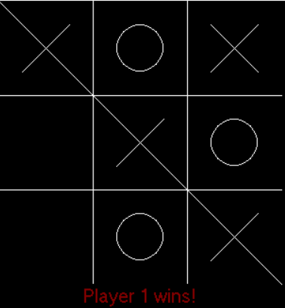

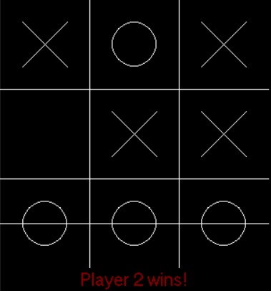

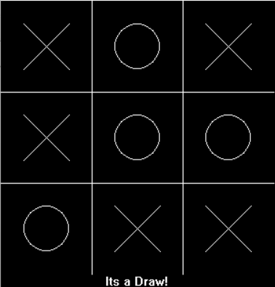

# Conclusion:

In this project, we developed a Tic Tac Toe game using the **graphics.h** library in C++. The game allows two players to take turns and place their 'X' or 'O' symbols on a 3x3 grid through mouse clicks. We implemented basic graphics functions to draw the grid, symbols, and detect win conditions. The game also allows players to enter their names, and upon a win, the winning player's name is displayed alongside the winning move. The use of **textwidth()** and **textheight()** functions improved text alignment. It provides a foundation for understanding graphics programming in C++ and can be extended with additional features in the future.